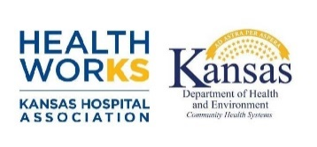

**Employee Health, Wellness and Safety Cohort Participant Agreement**

Project Contact:

Email Address:

Facility Name:

City:

Phone:

***YES****, our facility would like to commit to participate in the Employee Health, Wellness and Safety Cohort from June to November 2024. We agree to participate in all phases of this multi-hospital collaborative. Our facility understands this commitment requires the support of administrative leadership to meet the expectations outlined below.*

# Collection to Action Coalition

Sponsored by KDHE FLEX

________________________________________________________________________________________

/ /24

### CEO/Administrator Signature

### Facility Project Contact/Lead

#### Date

**Facility expectations:**

* Payment of **$250 project participation fee**. Make checks payable to Healthworks.
* Commit to and participate in Kick Off meeting in Wichita on June 6
* Commit to and participate in all working sessions – virtual and in person.
* Provision of staff time and resources necessary for commitment to the project. This includes project work within your facility, which will be ongoing throughout the duration of the project.
* Participation in the development of and commitment to an ongoing, sustainable monitoring program.
* Maintain and submit a provided progress report to Healthworks project staff as requested.
* Commit to and participate in a Wrap Up session on November 7.

##### Healthworks will provide:

##### In person and virtual working sessions to provide a foundation and assist each facility with establishing internal goals.

* Basic employee health, wellness and safety program training and resources for strong program development.
* Facilitation of peer networking.
* Assistance on using employee health, wellness and safety tools and techniques for improvement.
* Access to employee health, wellness and safety program expertise and project management assistance.
* A wrap up meeting at the conclusion of the project to celebrate successes and build the plan for sustainability within your organization.

**Please return no later than May 1**

**Attn: Susan Pattie (spattie@kha-net.org)**

**Fax: 785-233-6955**